**Triggering of flip-flops**

The state of a flip-flop is switched by a momentary change in the input signal. This momentary change is called a trigger. In other words, the output of a flip flop can be changed by bringing a small change in the input signal with the help of **a clock pulse** or commonly known as **a trigger pulse.** When such a trigger pulse is applied to the input, the output changes and thus the flip flop is said to be triggered. Flip flops are applicable in designing counters or registers which stores data in the form of multi-bit numbers. But such registers need a group of flip flops connected to each other as sequential circuits. And these sequential circuits require trigger pulses. **The number of trigger pulses** that is applied to the input of the circuit determines the **number in a counter.**

In the case of SR Flip Flops, the change in signal level decides the type of trigger that is to be given to the input. But the original level must be regained before giving a second pulse to the circuit. If a clock pulse is given to the input of the flip flop, the output of the flip flop is changing; it may cause instability to the circuit. The reason for this instability is the feedback that is given from the output combinational circuit to the memory elements. This problem can be solved to a certain level by making the flip flop more sensitive to the pulse transition rather than the pulse duration.

There are mainly four types of pulse-triggering methods. Sometimes they are also categorized into just two (positive and negative). They differ in the manner in which the electronic circuits respond to the pulse. They are high level, low level, negative and positive triggering.

**1. High Level Triggering**

When a flip flop is required to respond at its HIGH state,  a HIGH level triggering method is used. It is mainly identified from the straight lead from the clock input. Take a look at the symbolic representation shown below.

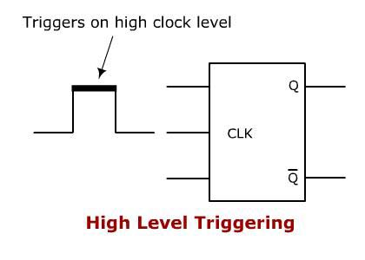

High Level Triggering

**2. Low Level Triggering**

When a flip flop is required to respond at its LOW state,  a LOW level triggering method is used.. It is mainly identified from the clock input lead along with a low state indicator bubble. Take a look at the symbolic representation shown below.

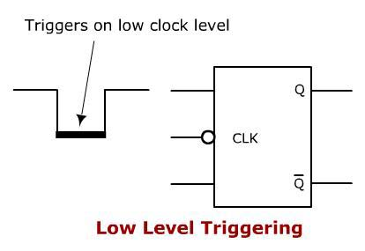

Low Level Triggering

**3. Positive Edge Triggering**

When a flip flop is required to respond at a LOW to HIGH transition state,  POSITIVE edge triggering method is used. It is mainly identified from the clock input lead along with a triangle. Take a look at the symbolic representation shown below.

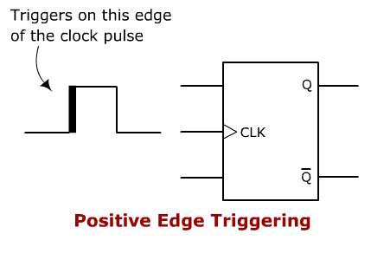

Positive Edge Triggering

**4. Negative Edge Triggering**

When a flip flop is required to respond during the HIGH to LOW transition state,  a NEGATIVE edge triggering method is used.. It is mainly identified from the clock input lead along with a low-state indicator and a triangle. Take a look at the symbolic representation shown below.

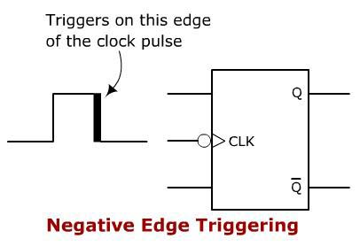

Negative Edge Triggering